**FINAL SEMESTER INTERNSHIP REPORT IV B.TECH II SEMESTER(2024-2025)**

**ON**

**FULL STACK WEBSITE DEVELOPMENT**

***An Internship Report Submitted to* JNTU,Anantapuramu**

*In partial fulfillment of the requirements for the award of the degree of*

## Bachelor of Technology Computer Science & Engineering

By

| **Name of Student** | Anjali Sanniboina |
| --- | --- |
| **Roll Number** | 21KB1A05E8 |
| **Organization** | Green Tech Industries Ind Pvt Ltd |
| **Name of Supervisor** | D.Viswanath Reddy |

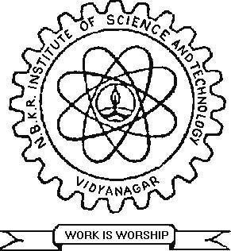

**DEPARTMENT OF COMPUTER SCIENCE AND ENGINEERING**

**N.B.K.R. INSTITUTE OF SCIENCE & TECHNOLOGY**

**(Autonomous)**

VIDYANAGAR – 524 413, TIRUPATI DIST, AP

**Student’s Declaration**

I, Anjali Sanniboina, a student of Btech program, Roll No. 21KB1A05E8 of the Department of CSE,NBKRIST College do hereby declare that I have completed the mandatory internship in Green Tech Industries under the guideship of D.Viswanath Redd.Department of CSE,NBKRIST

***(Signature and Date)***



**CERTIFICATE OF INTERNSHIP**

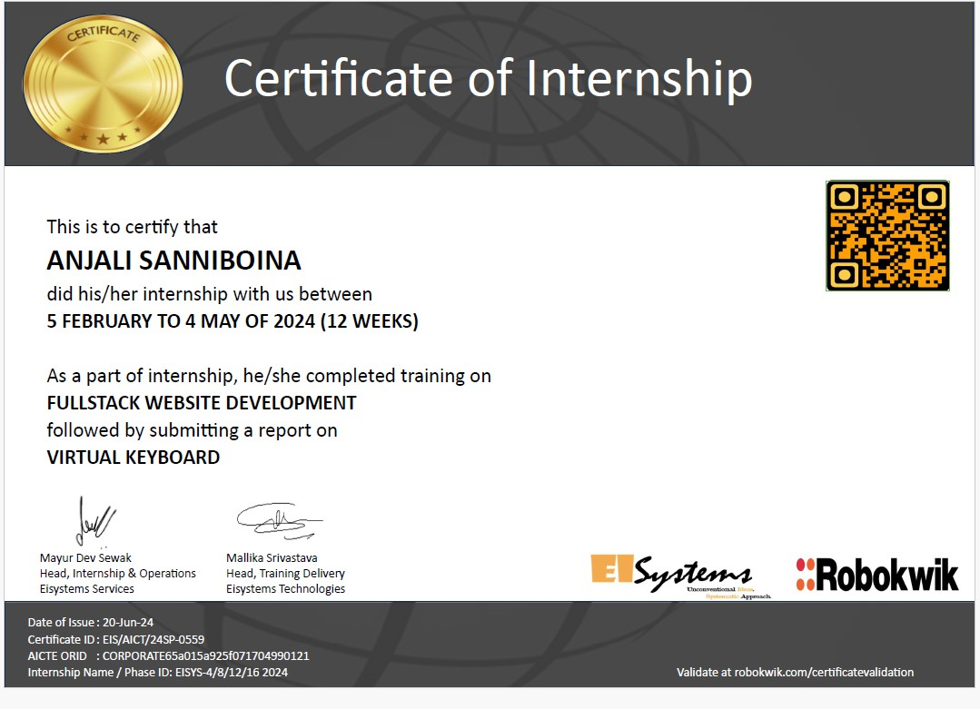

**ACKNOWLEDGEMENT**

The satisfaction that accompanies the successful completion of a project would be

incomplete without the people who made it possible of their constant guidance and encouragement

crowned our efforts with success.

We would like to express our profound sense of gratitude to our project guide

Mr.K.Penchalaiah, Assistant Professor & Department of Computer Science & Engineering,

N.B.K.R.I.S.T (affiliated to JNTUA, Ananthapuramu), Vidyanagar, for his masterful guidance and

the constant encouragement throughout the project. Our sincere appreciation for his suggestions and

unmatched services without, which this work would have been an unfulfilled dream.

We convey our special thanks to Dr. Y. Venkata Rami Reddy, respectable Chairman,

N.B.K.R. Institute of Science & Technology, for providing excellent infrastructure in our campus

for the completion of the project.

We convey our special thanks to Sri N. Ram Kumar , respectable Correspondent,

N.B.K.R. Institute of Science & Technology, for providing excellent infrastructure in our campus

for the completion of the project.

We are grateful to Dr. V. Vijaya Kumar Reddy, Director ,N.B.K.R. Institute of Science

& Technology for allowing us to avail all the facilities in the college.

We express our sincere gratitude to Dr.A.Rajasekhar Reddy, Professor, Head of the

Department , N.B.K.R. Institute of Science & Technology, for providing exceptional facilities for

successful completion of our project work.

We would like to convey our heartful thanks to Staff members, Lab technicians, and our

friends, who extended their cooperation in making this project as a successful one.

We would like to thank one and all who have helped us directly and indirectly to

**S.ANJALI (21KB1A05E8)**

**ABSTRACT**

The objective of this internship in full stack website development is to immerse interns in a dynamic and engaging learning environment, enabling them to gain hands-on experience and valuable insights across a range of web technologies. Our primary aim is to empower interns with the essential skills and knowledge required to effectively develop and manage both front-end and back-end components of web applications, with a specific emphasis on industry-standard frameworks and tools. Throughout the internship duration, interns will engage in a structured curriculum designed to provide comprehensive coverage of web development fundamentals and advanced concepts.

By actively participating in hands-on activities, practical exercises, and real-world projects, interns will cultivate a robust understanding of key principles, including user interface design, server-side programming, database management, API integration, and version control practices. As interns progress through the program, they will receive mentorship and guidance from experienced professionals in the field, enabling them to refine their technical abilities, enhance problem-solving skills, and develop a mindset geared towards innovation and continuous improvement.

Additionally, regular evaluations and feedback sessions will provide interns with valuable insights into their performance, allowing them to identify areas for growth and tailor their learning journey to align with their individual career aspirations. Ultimately, the overarching goal of this internship is to equip interns with the requisite knowledge, skills, and confidence to navigate the complexities of full stack web development effectively. By fostering a dynamic learning environment and providing hands-on experiences with leading web technologies, we aim to empower interns to emerge as proficient and versatile web developers, poised to make meaningful contributions to the rapidly evolving landscape of technology and digital innovation.



**ORGANIZATION’S INFORMATION**

The organization where I had the opportunity to undertake my Full Stack website development internship,EI Systems is a distinguished entity in the web technologies,particularly renowed for its expertise and innovations in many fields.Located in Uttar Pradesh.Catering to a wide range of businesses and industries.

# VISION AND MISSION

## Vision:

The company envisions being a frontunner in the web technologyrevolution,specifically by harnessing the power and versatility of Full Stack to transform and elevate business process across various sectors.

## Mission:

Dedicated to delivering robust,innovative ,and scalable solutions,the company’s mission is to empower organizaions by optimizing their operations throught efficient and effective integration.

# CORE VALUES

## Innovation:

Emphasizing the importance of continuos innovation and the adoption of emerging technologies to stay a head in the industry.

## Excellence:

Commitment to delivering the highest quality in evry project ,ensuring client satisfaction through superior solutions

## Integrity:

Upholding ethical practices and transparency in all business dealings.

## Customer Focus:

Ensuring that the needs and expecations of clients are consistently met and exceeded.

# ACHIEVEMENTS

EISystems Services is a leading Indian technology identity with operations across India. EISystems (EISys) offers trainings in Cybersecurity, Machine Learning, Automobiles, Internet of Things, Robotics and Socialmedia for enterprises and student community. Till date it has trained approximately 50000 students and impacted around 2 lakhs students through various outreach initiatives since their founding.



**WEEKLY OVERVIEW OF INTERNSHI ACTIVITIES**

**Week 1**: Introduction to Full Stack Development Overview:

Introduce the concept of full stack development and the technologies involved.

Activities:

* Overview of front-end vs. back-end development.
* Introduction to popular tech stacks (e.g., MERN, LAMP).
* Hands-on tutorials on setting up a development environment (Node.js, npm, Git).

**Week 2:** HTML and CSS Fundamentals Focus:

Learn the basics of web page structure and styling.

Activities:

* Hands-on exercises creating static web pages using HTML5.
* Introduction to CSS3 for styling and layout (Flexbox, Grid).
* Project: Build a simple static website.

**Week 3**: JavaScript Basics Focus:

Understand JavaScript fundamentals for client-side scripting.

Activities:

* Learn core JavaScript concepts (variables, functions, loops, events).
* Hands-on tutorials with DOM manipulation.
* Project: Enhance the static website with JavaScript interactivity. Week 4: Version Control with Git

Focus:

Learn the importance of version control in development. Activities:

* Introduction to Git and GitHub for version control.
* Hands-on exercises: cloning repositories, making commits, branching, and merging.
* Project: Collaborate on a small group project using Git.

**Week 5:** Introduction to Front-End Frameworks Focus:

Explore modern front-end frameworks for building dynamic applications.

Activities:

* Overview of frameworks (React, Vue.js, Angular).
* Introduction to React: components, state, and props.
* Project: Build a simple application using React.



**Week 6**: Back-End Development Basics Focus:

Understand the server-side of web applications.

Activities:

* Introduction to Node.js and Express.js.
* Build a simple RESTful API with Express.
* Project: Create a basic server to handle CRUD operations.

**Week 7**: Databases and Data Management Focus:

Learn about databases and how to integrate them with applications.

Activities:

* Introduction to SQL (PostgreSQL/MySQL) and NoSQL (MongoDB) databases.
* Hands-on setup of a database and connecting it to a server.
* Project: Implement data storage in your back-end application.

**Week 8**: User Authentication and Authorization Focus:

Implement user management in your application.

Activities:

* Learn about authentication strategies (JWT, OAuth).
* Hands-on implementation of user sign-up and login.
* Project: Add authentication to your application.

**Week 9**: Building Full Stack Applications Focus:

Integrate front-end and back-end components.

Activities:

* Connect the React front end to the Express back end.
* Hands-on project: Create a full stack application with CRUD functionality.
* Discussion on best practices in full stack development.

**Week 10:** API Development and Integration Focus:

Learn how to consume and create APIs.

Activities:

* Overview of RESTful APIs and GraphQL.
* Hands-on exercise: Consume a public API in a front-end application.
* Project: Build and document your own RESTful API.

**Week 11**: Deployment and Hosting Focus:

Learn how to deploy web applications.



Activities:

* Introduction to cloud hosting services (Heroku, AWS, Vercel).
* Hands-on tutorial: Deploy your application to a cloud platform.
* Discussion on continuous integration and delivery (CI/CD).

**Week 12:** Performance Optimization and Testing Focus:

Improve application performance and reliability.

Activities:

* Learn about web performance optimization techniques.
* Introduction to testing frameworks (Jest, Mocha).
* Hands-on project: Write tests for your application and optimize performance.



**OUTCOME**

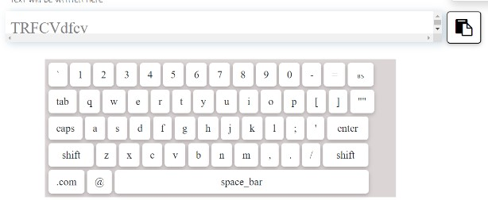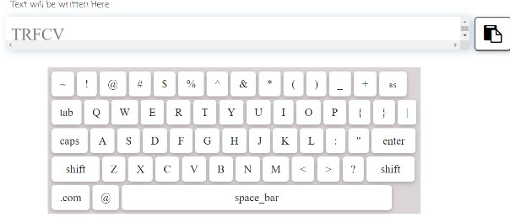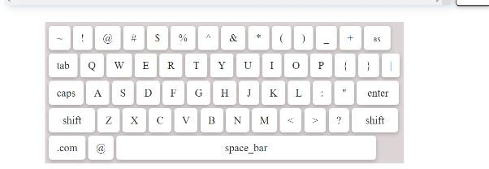



**CONCLUSION**

Reflecting on the Full Stack Web Development internship, it is evident that this experience has been a pivotal chapter in my professional journey. The internship served as an invaluable opportunity to bridge the gap between theoretical knowledge and practical application, greatly enhancing my skills and understanding of full stack development processes. The exposure to a professional environment, combined with the opportunity to work on diverse, real-world projects, proved to be essential in preparing me for a career in the technology sector.

The challenges encountered and overcome during this period not only honed my technical abilities but also contributed significantly to my personal and professional growth. From enhancing my communication and teamwork skills to developing a resilient and adaptable mindset, the internship has shaped me into a more well-rounded individual and professional.

Inspired by this experience, I have set forth clear goals and aspirations for my future. These goals reflect a commitment to continual learning and specialization in web development technologies. The relationships and professional network I developed during the internship are assets I cherish and look forward to nurturing as I advance in my career.

In conclusion, the Full Stack Web Development internship at [Company Name] has been an immensely rewarding and transformative experience. It has not only affirmed my passion for web development but also set me on a path of lifelong learning and professional growth in the dynamic world of technology. The skills, knowledge, and experiences gained during this period have laid a solid foundation for my future endeavors, positioning me well for success in the ever-evolving landscape of web development.

